**ATAR HUMAN BIOLOGY**

**Unit 2**

**Task 9 : DNA, Cell & Human Reproductive Systems**

**Name:**  **Weighting 5%**

**Date:**  **Mark /**

1. There are THREE sections in this test, Multiple Choice, Short Answer and Extended Answer.
2. This is a closed book assessment (no notes are allowed)
3. The time allowed to complete the test is 60 minutes
4. Write your answers to the Multiple Choice section on the **separate** answer sheet provided.
5. Write your answers to the Short Answer section in space provided.
6. Write your answers to the Extended Answer section in space provided.

|  |  |  |
| --- | --- | --- |
|  | **Marks Allocation** | **Your Total** |
| **Multiple Choice** | 10 |  |
| **Short Answer** | 42 |  |
| **Extended Answer** | 10 |  |
| **TOTAL** | 62 |  |

**ATAR HUMAN BIOLOGY**

**TEST: DNA, Cell & Human Reproductive Systems**

**Name: ______________**

**Multiple Choice Answer Sheet**

Answer all questions by circling the letter corresponding to the most correct answer.

1. A B C D

2. A B C D

3. A B C D

4. A B C D

5. A B C D

6. A B C D

7. A B C D

8. A B C D

9. A B C D

10. A B C D

**Part A - Multiple Choice Questions (10 Marks)**

1. Which of the following statements is **NOT** true about mitosis?

a) Mitosis results in the formation of 2 daughter cells identical to the parent cell.

b) Takes place all over the body.

c) Involves the use of RNA in the duplication of chromosomes.

d) Is used for growth and repair of the body cells.

1. Artificial hormone pills have been helpful when given to some people who have been

unable to have children; however, the dosage of these pills has to be carefully regulated

because an over-dose can cause multiple births. This implies that the effect of the hormone

is to:

a) stimulate ovulation in the woman.

b) stimulate sperm production in the man.

c) ensure that the embryos remain fixed in the uterus.

d) increase sexual desire.

1. The greatest chance for an ovum to be fertilised, is having sexual intercourse:
2. at the beginning of the menstrual flow.
3. two weeks after menstruation starts.
4. at the end of the menstrual flow.
5. at the end of the menstrual cycle.

1. In meiosis, the chromosome number is halved in order to:

a) ensure the DNA is copied completely.

b) maintain all the DNA in the daughter cells.

c) ensure that errors in crossing-over can be corrected at fertilisation.

d) maintain the correct chromosome number in offspring.

1. The main purpose of the fluid produced by the seminal vesicle is to:
2. lubricate the urethra.
3. help activate the sperm.
4. provide sugar for the sperm for energy.
5. cause the final maturation of the spermatozoa.
6. Which of the following is NOT correct regarding spermatogenesis?
7. It begins before birth then ceases until after puberty.
8. It occurs continually after puberty.
9. The process takes about 72 days.
10. One spermatogonium results in four viable spermatozoa.
11. Proliferation describes the :
12. the differentiation of cells.
13. the specialisation of cells.
14. the rapid division of cells.
15. the growth of cells.
16. The embryo is surrounded by the amniotic cavity, filled with amniotic fluid. This fluid:
17. acts as a shock absorber
18. provides a medium through which the exchange of materials takes place between the mother and embryo
19. helps to regulate a constant temperature
20. produces hormones for the developing embryo
21. i and iv only
22. ii and iii only
23. i and ii only
24. i and iii only
25. Which of the following consists of both maternal and foetal tissue?
26. Placenta.
27. Umbilical cord.
28. Amnion.
29. Foetus.
30. Which of the following substances would be in higher concentration in the umbilical arteries than in the umbilical vein?
31. Glucose.
32. Amino acids.
33. Vitamins.
34. Carbon dioxide.

**Short Answer Section (43 marks)**

Use the following diagram of the male reproductive system to answer question one.

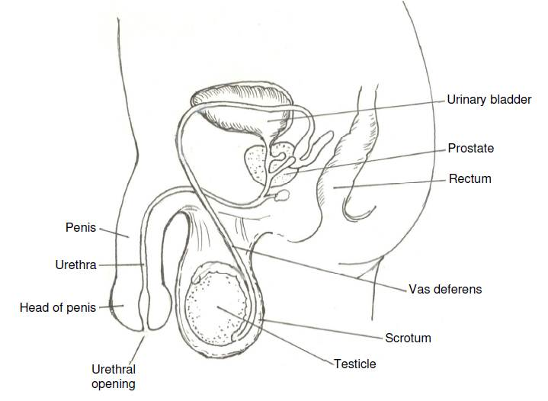

**F**

**G**

**H**

**C**

**B**

**A**

**E**

**D**

1. a) Label the following structures: (2 marks)

A: _______________________________________

C: _______________________________________

1. State the function of the following structures: (2 marks)

E : ______________________________________________________________________

_________________________________________________________________________

G: _____________________________________________________________________

_________________________________________________________________________

1. If a male developed prostate cancer and had to have his prostrate removed would he still be able to have children with his partner by natural means? Explain your answer. (3 marks)

________________________________________________________________________________________________________________________________________________________________________________________________________________________________________________________________________________________________________________________________________________________________________________________________________________________________________________________________________________________________________________________________________________________________________________________________________

Use the diagram of the ovary shown below to answer question 2.

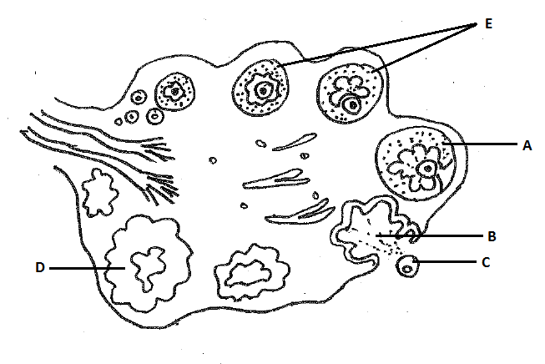

2. a) What role does structure D play in the menstrual cycle? (1 mark)

__________________________________________________________________________________________________________________________________________________

b) Describe the hormonal sequence of events that enable “C” to be released from the ovary. (2 marks)

_____________________________________________________________________________________________________________________________________________________________________________________________________________________________________________________________________________________________________________________________________________________________________________

c) Complete the following table on the major stages of the menstrual cycle. (5 marks)

|  |  |  |
| --- | --- | --- |
| **Stage** | **Time span** | **Events** |
| Menstruation | 1-4 |  |
| Preovulation | 5-12 | Endometrial repair; development of ovarian follicle;  Uterine lining gradually thickens |
|  | 13-15 |  |
| secretion | 16-20 | Secretion of watery mucus by glands of endometrium,  cervix and uterine tubes; |
|  | 21-28 |  |

3. Many features of both reproductive systems depend on the endocrine glands for their regulation. The endocrine glands produce many hormones; each hormone has a specific target organ and effect that it causes.

Complete the following table identifying the hormones’ specific target organ(s) and the effect(s) in males or females. (3 marks)

|  |  |  |
| --- | --- | --- |
| **Hormone** | **Target organ(s)** | **Effect(s) of hormone** |
| HCG – Human Chorionic Gonadotrophin |  |  |
| Testosterone |  |  |

4. Outline the pathway of a sperm from its release from the epididymis to its ejaculation in semen from the body. Include the major events that occur along the way. (5 marks)

_______________________________________________________________________________________________________________________________________________________________________________________________________________________________________________________________________________________________________________________________________________________________________________________________________________________________________________________________________________________________________________________________________________________________________________________________________________________________________________________________________________________________________________________________________________________________________________________________________________________________________________________________________________________________________________________________________________________________________________________________________________________________________________________________________________________________________________________________________

5. Use the table below to complete the summary of mitosis. Name the stages described or outline the key events occurring at each stage named. NOTE: Stages are NOT listed IN ORDER. (5 marks)

|  |  |
| --- | --- |
| Stage | Events |
|  | Nuclear membranes and nucleoli form; chromosomes uncoil and disappear |
| Anaphase |  |
|  | Cytoplasm of the cell divides into 2, each with a new nucleus. |
|  | DNA molecules replicate |
| Metaphase |  |
|  |  |

7. Use the diagram below to answer the following questions.

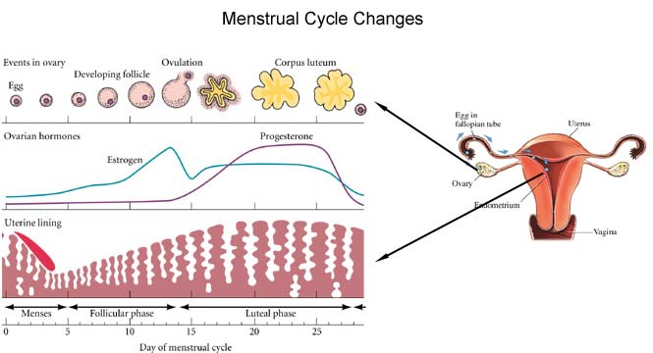

What hormones are represented by the lines on the graph and explain how you came to your conclusion. (3 marks)

____________________________________________________________________________________________________________________________________________________________________________________________________________________________________________________________________________________________________

8. Once the zygote has been formed it will go through many changes before being brought into the world

a) Explain what is meant by the term cell differentiation? (1 mark)

___________________________________________________________________ ___________________________________________________________________

b) Give two reasons why the best place for fertilisation of the egg to occur is midway along the fallopian tube. (2 marks)

___________________________________________________________________

___________________________________________________________________

___________________________________________________________________

c) There are three primary germ layers that develop within the blastocyst, give two examples of structures that will be formed by each of the primary germ layers. (3 marks)

Endoderm __________________________________________________________

Mesoderm __________________________________________________________

Ectoderm ___________________________________________________________

9. Once the blastocyst implants the placenta starts to form and takes about 3 months till it is fully functional. Discuss why an embryo/foetus would need such an organ as the placenta. (4 marks)

_________________________________________________________________________

___________________________________________________________________________________________________________________________________________________________________________________________________________________________________________________________________________________________________________________________________________________________________________________________________________________________________________________________________________________________________________________________________________________________________________________________________________________________________________________________________________________________________________________________________________________________________________________________________________________________________

**EXTENDED ANSWER QUESTION (10 marks)**

1. With the aid of diagrams, discuss the similarities and differences between spermatogenesis and oogenesis.

___________________________________________________________________________________________________________________________________________________________________________________________________________________________________________________________________________________________________________________________________________________________________________________________________________________________________________________________________________________________________________________________________________________________________________________________________________________________________________________________________________________________________________________________________________________________________________________________________________________________________________________________________________________________________________________________________________________________________________________________________________________________________________________________________________________________________________________________________________________________________________________________________________________________________________________________________________________________________________________________________________________________________________________________________________________________________________________________________________________________________________________________________________________________________________________________________________________________________________________________________________________________________________________________________________________________________________________________________________________________________________________________________________________________________________________________________________________________________________________________________________________________________________________________________________________________________________________________________________________________________________________________________________________________________________________________________________________________________________________________________________________________________________________________________________________________________________________________________________________________________________________________________________________________________________________________________________________________________________________________________________________________________________________________________________________________________________________________________________________________________________________________________________________________________________________________________________________________________________________________________________________________________________________________________________________________________________________________________________________________________________________________________________________________________________________________________________________________________________________________________________________________________________________________________________________________________________________________________________________________________________________________________________________________________________________________________________________________________________________________________________________________________________________________________________________________________________________________________________________________________________________________________________